CS 255 System Design Document Template

UML Diagrams

UML Use Case Diagram
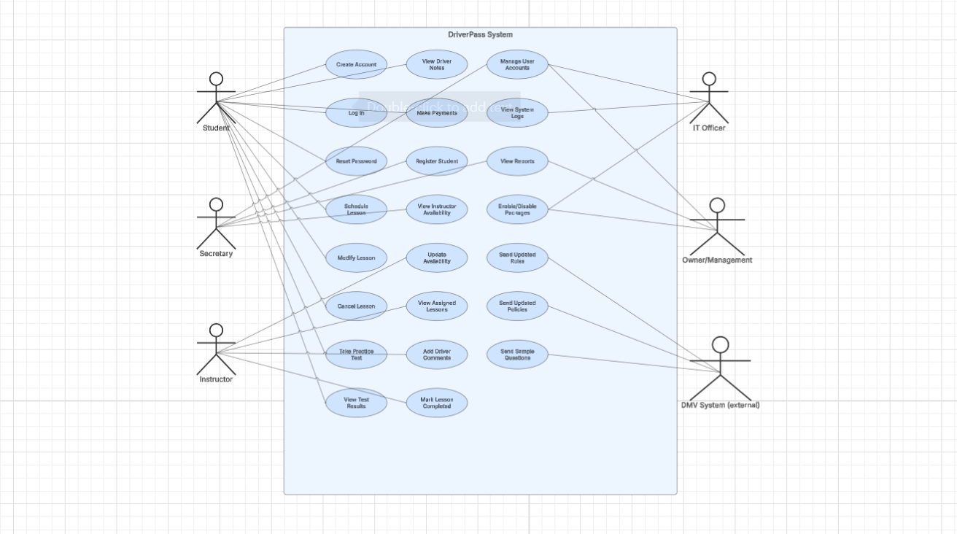

UML Activity Diagrams
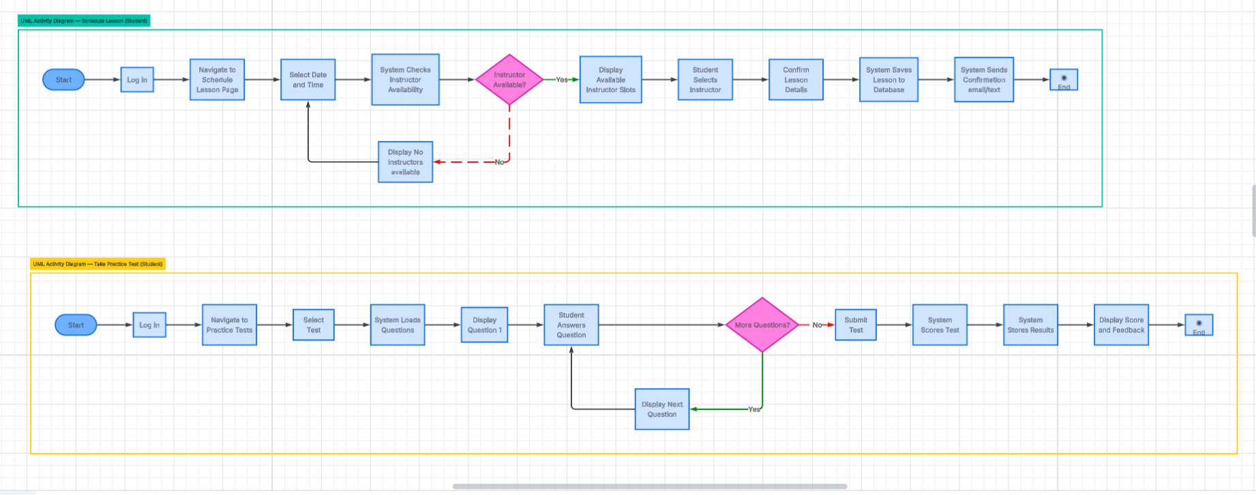

UML Sequence Diagram
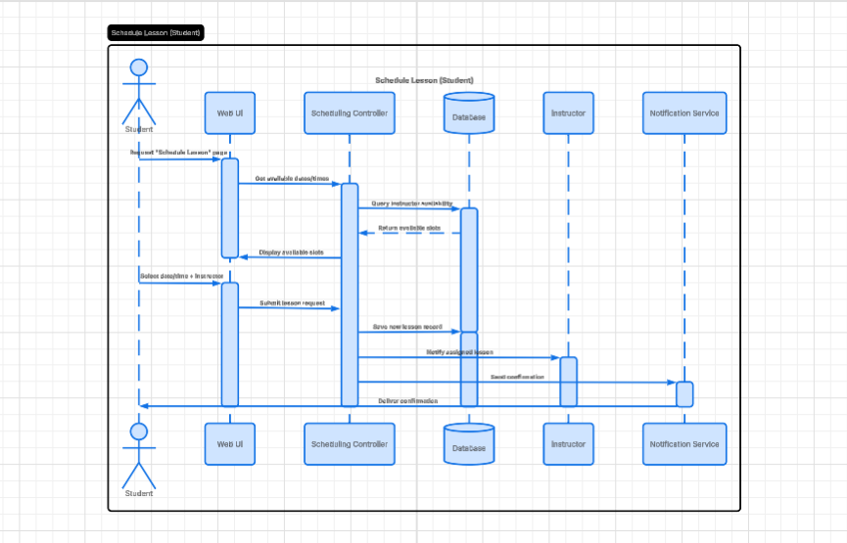

UML Class Diagram
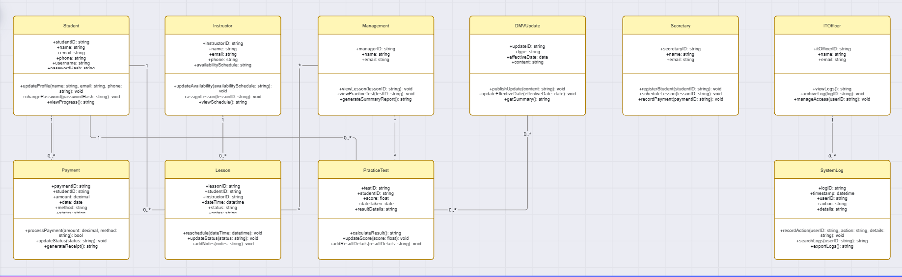

Technical Requirements
The DriverPass system requires a combination of hardware, software, development tools and infrastructure to support scheduling lessons managing user accounts, processing payments delivering DMV updates and providing online practice tests. The following technical requirements are derived directly from the UML use case activity sequence and class diagrams.
- Hardware Requirements
Client-Side (Students, Instructors, Staff)
- Desktop or laptop computer with modern web browser
- Mobile device(optional) for receiving notifications
- Reliable internet connection (minimum 10 Mbps)
Server-Side
- Cloud-hosted or on-premises application server capable of running a web application
- Minimum specifications:
  - Quad-core CPU
  - 16 GB RAM
  - SSD storage (250 GB or higher)
- Dedicated databases server or cloud database instance
- Backup storage for logs, lesson history and DMV updates

- Software Requirements
Frontend
- HTML5, CSS, JavaScript
- Modern frontend framework(optional): React, Angular or Vue
- Responsive design to support desktop and mobile access
Backend (Scheduling Controller, Authentication, Business Logic)
- Server-side language such as Java, C#, Python or Node.js
- RESTful API endpoints for lesson scheduling, test retrieval, payments and user management
- Authentication and authorization framework (JWT or OAuth2
Database
- Relational database management system (RDBMS)
  - MySQL, PostgreSQL or SQL Server
- Tables required
  - Student
  - Instructor
  - Secretary
  - ITOfficer
  - Management
  - Lesson
  - PracticeTest
  - Payment
  - DMVUpdate
  - SystemLog
Notification Services
- Email Delivery service (SendGrid, AWS SES, or SMPT server)
- Optional SMS gateway for text confirmation
DMV Integration
- Secure API endpoint or schedule data import for DMV rules, policies and sample questions
- Data validation and storage in DMVUpdate table

- Tools and Development Environment
- UML Diagramming tool (Lucidchart)
- Version control system (GitHub, GitLab, or Azure DevOps)
- IDE such as IntelliJ, Visual Studio, VS Code or Eclipse
- Unit testing framework (Junit, NUnit, PyTest, Jest)
- Continuous Integration/Deployment (CI/CD) pipeline (GitHub, Actions, Jenkins, Azure DevOps)

- Security Requirements
- Encrypted passwords storage using hashing (bcrypt or SHA-256)
- Role-based access control for Student, Instructor, Secretary, IT Officer, and Management
- HTTPS for all web traffic
- Input validation to prevent SQL injection and cross-site scripting
- Logging and auditing of all administrative actions (SystemLog class)

- Infrastructure Requirements
Hosting
- Cloud hosting platform such as AWS, Azure, or Google Cloud
- Load balancer for high-traffic periods (e.g., practice test usage)
- Auto-scaling for backend services
Data Storage and Backupk
- Daily automated backups of database
- Redundant storage for DMV updates and lesson history
- Log retention policy for IT Officer auditing
High Availability
- 99.9% uptime SLA
- Failover support for database and application servers

- Functional Requirements Supported by the System
- Students can create accounts, log in, schedule lessons, take practice tests and make payments.
- Instructors can update availability, view assigned lessons, and add driver comments
- Secretaries can register students and manage lessons scheduling
- IT officers can manage user accounts and system logs.
- Management can view reports and student progress
- DMV updates are stored and used to generate practice test content
- The system sends automated email/text confirmations for schedule lessons

